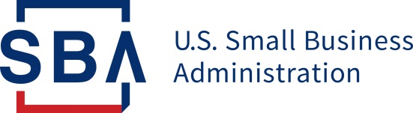
NEWS RELEASE

PRESS OFFICE

Release Date: March 23, 2020 Contact: Press_Office@sba.gov, (202) 205-7036
Release Number: 20-27 Follow us on Twitter, Facebook, Blogs & Instagram

Carranza Implements Automatic Deferment on Existing SBA Disaster Loans Through End of 2020

WASHINGTON – Today, U.S. Small Business Administration Administrator Jovita Carranza announced changes to help borrowers still paying back SBA loans from previous disasters. By making this change, deferments through December 31, 2020, will be automatic. Now, borrowers of home and business disaster loans do not have to contact SBA to request deferment.

“The SBA is looking at every option and taking every action to cut red tape to make it easier for small businesses to stay in business. Automatically deferring existing SBA disaster loans through the end of the year will help borrowers during this unprecedented time,” said Administrator Carranza. “Today’s announcement adds a list of growing actions the SBA is taking to support small businesses. These actions include making it easier for states and territories to request a declaration so small businesses statewide can now apply for economic injury disaster loans, and changing the terms of new economic injury loans to allow for one-year deferments. We are working around the clock to find ways to assist small businesses and today’s action is one step in this process.”

Previous Announcement:
March 17, 2020: SBA Updates Criteria on States for Requesting Disaster Assistance Loans for Small Businesses Impacted by Coronavirus (COVID-19)

Visit SBA.gov/Coronavirus for more information on SBA’s assistance to small businesses.

###

About the U.S. Small Business Administration
The U.S. Small Business Administration makes the American dream of business ownership a reality. As the only go-to resource and voice for small businesses backed by the strength of the federal government, the SBA empowers entrepreneurs and small business owners with the resources and support they need to start, grow or expand their businesses, or recover from a declared disaster. It delivers services through an extensive network of SBA field offices and partnerships with public and private organizations. To learn more, visit www.sba.gov.

